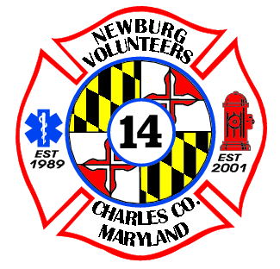BOWFISHING

BIG 5 TOURNAMENT

OFFICIAL REGISTRATION FORM – BOWFISHING TOURNAMENT

The tournament is scheduled for Saturday, May 20th – Sunday, May 21st, 2023 at Newburg Volunteer Rescue Squad & Fire Department.

Check-In: Saturday, May 20th 3-5PM Captain’s Meeting: May 20th at 5:30 at PM

Fishing Starts: Saturday May 20th at 7PM Weigh-In: Sunday, May 21st at 7AM

Registration Fee Per Boat: $200 up to 4 people

* Cash
* Credit Card

Mystery Pot Fee $20 each: __#__________ (WINNER TAKE ALL)

* Cash
* Credit Card TOTAL: ______

Captain’s Name: ____________________________________ PHONE: ______________

Adress: _________________________________________________________________

City: ___________________________ State: ________ ZIP: __________

Email – Please print legible: __________________________________________________

Name & Length of Boat: _____________________________________________________

Launch Point: _____________________________________________________________

Secondary Contact on board Vessel: __________________________________________

Emergency Conact: Name_____________________Phone Number:______________________

**I give permission for NVRSFD to post pictures of the event. **

SIGN: _____________________________________ Date: _________________